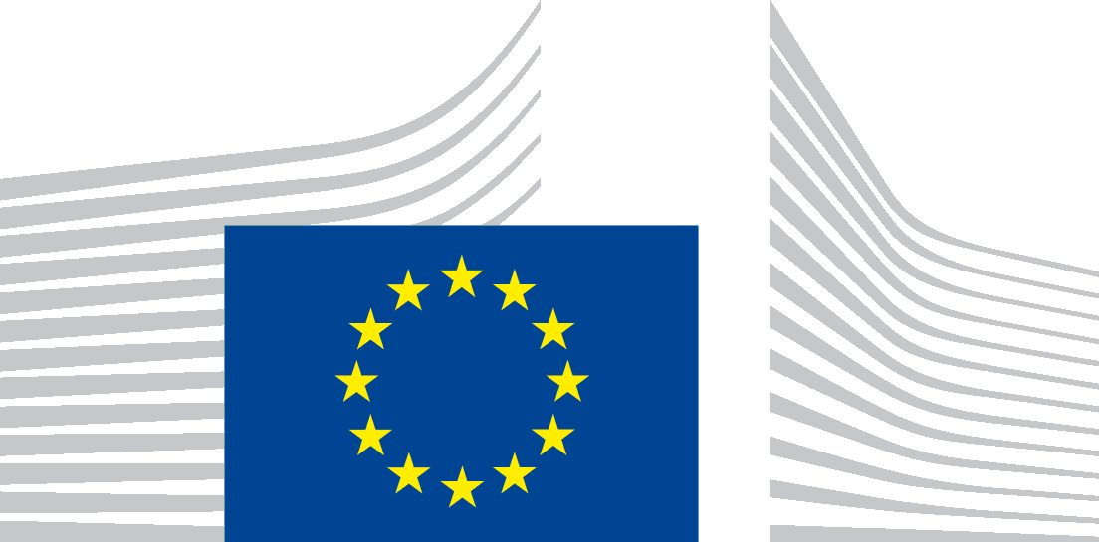 | EUROPEAN COMMISSION  DIRECTORATE-GENERAL FOR ENERGY  Directorate C - Renewables, Research and Innovation, Energy Efficiency  C.3 - Energy efficiency
Brussels, 9 December 2016

Report to the Ecodesign Consultation Forum on the review of the appropriateness of setting separate requirements for different types of water heaters according to Article 7(2) of the Commission regulation (EU) No 814/2013 with regard to ecodesign requirements for water heaters and hot water storage tanks

Context
Commission Regulation (EU) No 814/2013 with regard to ecodesign requirements for water heaters and hot water storage tanks sets minimum requirements regarding the water heating energy efficiency of water heaters placed on the EU market. These requirements apply to all water heaters, independently of the fuel used.
Article 7(2) of this regulation requires the Commission to assess the appropriateness of setting separate ecodesign requirements for different types of water heaters. This review was to be reported to the Consultation Forum by September 2016 (two years before the general review of the regulation). One of the reasons for setting this earlier date is electric combination heaters and water heaters using the Joule effect to heat the water with tapping profiles XXL, 3XL and 4XL will be banned from September 2017 and September 2018 respectively due to the water heating energy efficiency requirements laid down in the regulation.
Therefore, a study was carried out to assess whether it would be appropriate to set separate water heating energy efficiency requirements for products using different fuels, including a preliminary assessment of the impact of the water heating energy efficiency requirements coming into force in September 2017 and September 2018, for combination heaters and water heaters respectively, with tapping profiles XXL, 3XL and 4XL.
This study started in November 2015 and was concluded in July 2016. During the course of the study stakeholders from Member States' authorities, industry, relevant standardisation technical committees and working groups, civil society, consumers and environmental NGOs were actively involved. One public stakeholder meeting was held in April 2016 (see annex I for the minutes of that meeting). The final version of the study can be found here.
This report to the Consultation Forum, in conjunction with this study, fulfils the Commission's obligations set out in Article 7(2) of Commission regulation (EU) 814/2013 on Ecodesign requirements for water heaters and hot water tanks.

Discussion
The setting of ecodesign requirements for energy-related products follows the so-called MEErP methodology which is based on a least life-cycle cost calculation of technology neutral design options. The resulting minimum efficiency requirements are then checked against the criteria described in Article 15.5. of the framework Directive 2009/125/EC. Only if it turns out that technology neutral requirements would lead to an unacceptable increase in e.g. product price or production costs, does the possibility of setting technology specific measures or targeted exceptions have to be investigated.

The review study shows that the least life cycle costs per load profile for the whole product group are not below the corresponding minimum efficiency levels set in the regulation.
Moreover, the study shows that the existing, technology neutral, ecodesign limits will not deprive consumers of adequate water heater solutions, even in extreme climate conditions or remote locations. Therefore, at this point in time, there seems to be no need for setting separate ecodesign requirements for different types of water heaters.
The full review of this regulation will be an opportunity to confirm this based also on further data that will be available at that time.

Conclusion
Based on the results of the review study, it is recommended not to set separate ecodesign requirements for different types of water heaters.

See http://ec.europa.eu/growth/industry/sustainability/ecodesign_en for more information about this methodology

